Q.1) Create a user in iam give him access of admin. Remove his admin access policy at 8:00 pm automate this task ?

🡺

Step 1:-

First of all you have to get access of user on aws cli by aws commands.

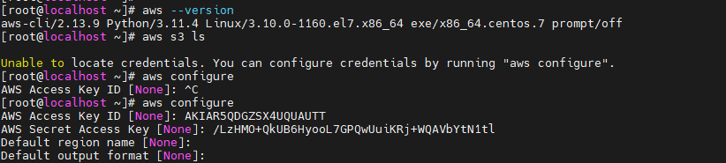

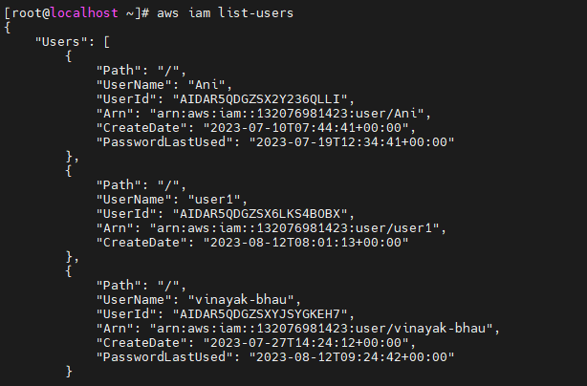

Step 2:-

Now you have to create user by run command “aws I am create-user –user-name demo_user”.

And your user was created. After that check user was created or not by run command to list users

“Aws iam list-user”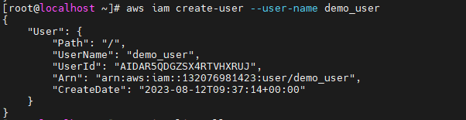

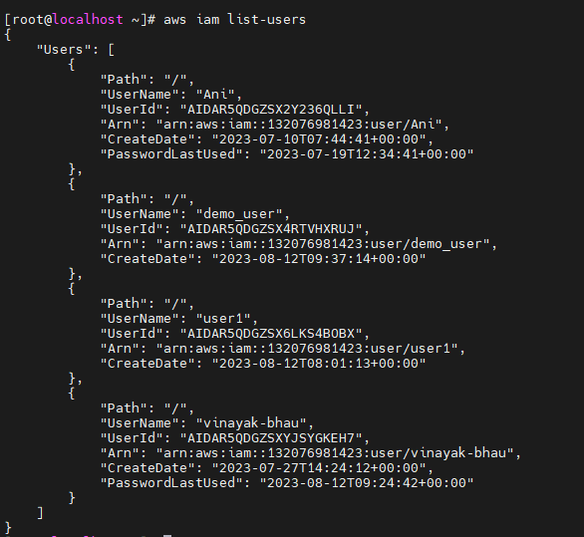

Step 3:-

Now you have gave that user a policy of admin full access by running command “aws iam attach-user-policy --user-name demo_user --policy-arn arn:aws:iam::aws:policy/AdministratorAccess”.



Step 4:-

Now demo_user have get attached a policy of admin access. So that users work is finishing after some time means 8 pm so we have to remove his permission on time by automatic. That’s why we have to schedule a task by crontab or other methods. So I will create corn job. Because I have get access of aws cli on linux so I create a crontab. First of all we have to create a script to detach users policy on particular time with the help of crontab. You can create user also in this .sh file but I will make user and then create .sh file to detach its policy. So see following step to how set up .ch file of detach policy.

Run a command #vim detach.sh and in that write this

aws iam detach-user-policy --user-name demo_user --policy-arn arn:aws:iam::aws:policy/AdministratorAccess



Step 5:-

Now you have to create crontab so run crontab –e command and it that write a five paths of your job and then write a absolute path of your .sh path. Script id “0 8 * * * /home/detach.sh”.

Detach.sh is my .sh file.

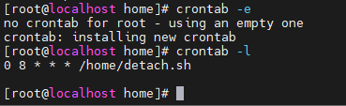

Step 6:-

And see your crontab is running or not by forcefully run your .sh file. Befoe run .sh script gave that .sh file a permission of 777. And then run ./sh file. Now see the user has detach policies or not by run command aws iam list-attached –user-name demo_user and see there was no police to user.

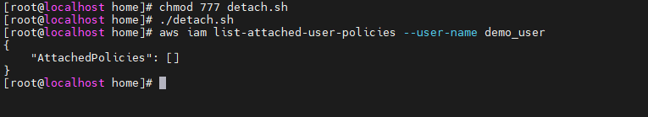

Step 7:-

If your .sh file was run then your crontab is run on time which you have schedule.



***The End***